

|  |  |  |  |  |  |  |  |  |
| --- | --- | --- | --- | --- | --- | --- | --- | --- |
|  | | | | | | | | |
|  | | Week 4 Lab: Green Vehicles Inc. | | | | |  | |
|  |  | | | | | | |  |
|  | | | |  |  | | | |
|  | | | | Christine Baxter |  | | | |
|  | | | | August 2, 2021—Developing and Managing Databases for Business IntelligenceBIAM530—Robert Burdwell |  | | | |
|  | | |  | | |  | | |



|  |  |  |  |  |  |  |  |  |
| --- | --- | --- | --- | --- | --- | --- | --- | --- |
|  |  | | |  |  | | |  |
|  | Abstract | | | | | | |  |
|  |  | | |  |  | | |  |
|  |  | |  | | |  | |  |
|  |  | Electric vehicles are the new buzz! They are more sophisticated, increasing in popularity, and become more efficient with each passing year. Vehicle manufacturers have stepped up to meet this increased interest in electric vehicles while becoming more environmentally centered. As a result, it is more important than ever that Green Vehicles Inc. (GVI) renew the company’s focus and commitment to selling and servicing the electric vehicles for their existing and new customers. | | | | |  |  |
|  | | | | |
|  |  |  |  |
|  |  |

|  |  |  |  |  |  |  |  |  |  |  |  |  |  |
| --- | --- | --- | --- | --- | --- | --- | --- | --- | --- | --- | --- | --- | --- |
|  | | | | | | | | | | | | | |
|  | | | Introduction | | | | |  | | | | | |
|  | | |  | |  |  | |  | | | | | |
|  | | Let’s face it, electric vehicles are the new buzz! They are more sophisticated, more popular, and more efficient with each passing year. Vehicle manufacturers have stepped up to meet this increased interest in electric vehicles while becoming more environmentally centered. As a result, it is more important than ever that Green Vehicles Inc. (GVI) renew the company’s focus and commitment to selling and servicing the electric vehicles for their existing and new customers.  To enhance this focus and commitment, the executive leadership team will be initiating a cross-dealership project with the desired outcome of optimizing the company’s inventory processes for “…optimal efficiency, productivity, and profitability” (DelVecchio, 2020). The executive leadership team wanted to advise their GVI managers on the best processes to follow as well as increase their understanding of the development process. GVI requested my assistance and expertise to review their current systems and processes then identify the most viable software/database development processes in addition to providing a recommended methodology and best practices to help ensure a successful implementation of the company-wide inventory management system.  After analyzing the current situation and processes, it was determined that GVI needs a centralized custom database system to efficiently manage their parts inventories. This document begins by discussing the selected software development process (SDLC) for the inventory management system, including major process steps and recommended methodology. It then moves onto the selected database development process (DBLC) for the inventory database and concludes with best practices to help ensure project success. | | | | | | | | |  | | | |
|  | | | | | | | | | | | |
|  | | | | Inventory Management System | | |  | | | | |
|  | | | |  |  |  |  | | | | |
|  | Current Inventory Process GVI customers bring their electric vehicles to the service department of their local dealership for recommended servicing/evaluation and repair work. Each car dealership must stock parts from the various manufacturers. If the needed part(s) is not in stock, service personnel must initiate phone call(s) to the other dealership service departments to locate the necessary part. If part is found at another dealership, delivery arrangements are implemented; otherwise, service personnel will have to place an order with their manufacturer for the specific part. Each dealership’s part department utilizes their own methods/processes for tracking inventory. Some are tracked by paper inventory logs and others use electronic systems that don’t meet all the GVI requirements. Software Development Process – SDLC Defined What exactly is SDLC and how will the selected SDLC help GVI implement an inventory management system? Let’s start with defining SDLC. In its most basic form, SDLC is a series of phases that provide a common understanding of the software building process. Two of the more popular SDLC models are Waterfall (or traditional approach) and Agile. According to John Sonmez - established author, blogger, and entrepreneur – a traditional SDLC is, “…a sequence of developing software that goes from requirements analysis to software design, to implementation, testing, deployment, and then finally maintenance.” (Sonmez, 2017). According to monday.com, an Agile SDLC model “…focuses on collaborative decision-making and development over multiple short cycles or sprints…” (monday.com, 2020; Figure 1). Now let’s dive into the selection process. | | | | | | | | |  | |
|  | | | | | | | | | | | |
|  | | | | Inventory Management System | | |  | | | | |
|  | | | |  |  |  |  | | | | |
|  | Software Development Process – SDLC Selection Choosing an appropriate approach to software development is a vital decision for a project team and can be mostly dependent on the nature of the project that needs developed including the company’s culture as well as the skills and experience of the project team. There are several SDLC models to choose from and they each have their own advantages and disadvantages (see Figure 2 for models). In addition, certain models work better with smaller projects/teams while others work better with larger, more involved projects/teams. SDLC models were evaluated to determine if they met the following three primary objectives: ensuring delivery of high-quality systems, providing strong management control, and maximizing productivity. No single model/methodology works effectively in all scenarios. As a result, many organizations utilize hybrid models which are a combination of two or more models/methodologies (Neelu & Kavitha, 2021).  For this inventory system management project, the Disciplined Agile (DA) method is highly recommended. DA, according to the Project Management Institute (PMI) website, “…is an agnostic, hybrid tool kit that harnesses hundreds of Agile, Lean, and traditional strategies…” the website continues to add that “DA guides you to the best way of working (WoW) for your team/organization”. Implementing this method within the GVI organization will teach the company how to get better at getting better, provide a solid foundation for enterprise agility, start where you are, and teach the company to become a learning organization. Lastly, DA will enable GVI the ability to experience true business agility versus being forced into a framework that does not meet GVIs needs and scale at the team and organization levels, growing with the company. (PMI, 2021). | | | | | | | | |  | |
|  | | | | | | | | | | | |
|  | | | | Inventory Management System | | |  | | | | |
|  | | | |  |  |  |  | | | | |
|  | Major Process Steps of Disciplined Agile There are four main process levels within the Disciplined Agile model/tool kit, and each have their own purpose and/or key process areas (KPAs). Figure 3 provides a graphical representation of the Foundation, Disciplined DevOps (DevOps), Value Streams, and Disciplined Agile Enterprise (DAE) process layers (PMI, 2021). This process decision framework integrates several agile best practices along with other non-agile methods into a comprehensive model that provides the company with flexible guidance for adapting and evolving in a context-sensitive manner. Figure 4 is an expanded version/overview of the DA tool kit, displaying the process blades/areas of the four main process layers. Recommended Methodology Disciplined Agile (DA) is the recommended methodology for GVIs inventory management system project. Please note that DA is not explicitly listed within the SDLC methodologies contained in Figure 2 as it is a tool kit that harnesses many Agile practices.  Adopting the DA tool kit (PMI, 2021):   1. Enables teams to get on a path of continuous improvement 2. Enables the rate of process improvement to increase 3. Supports the entire range of complexities faced by teams 4. Adopts pragmatic techniques from a wide range of agile, lean, and traditional sources 5. Supports all types of teams 6. Provides a consistent governance across disparate teams 7. Provides a foundation for business agility | | | | | | | | |  | |
|  | | | | | | | | | | | |
|  | | | | Inventory Database | | |  | | | | |
|  | | | |  |  |  |  | | | | |
|  | Database Development Process (DBLC) Each of GVIs dealerships are handling their parts inventory differently, a few of the dealerships are using Excel spreadsheets and others are using a more manual, paper method but all are experiencing similar challenges with keeping an up-to-date catalog. Management have noticed an adverse effect on customer satisfaction rates and a significant increase in administrative hours. GVI needs a database that is robust, efficient, cross-dealership accessible with expansive capabilities to stay competitive and further grow within their industry. To fully recognize the benefits of this new database, GVI also needs a compatible, reliable inventory management system that will improve process and staff efficiency, produce less waste and lower costs, and provide more effective long-term inventory planning (SKUBANA, 2020). It is important to note that the database development work should be completed in conjunction with the SDLC process described above to truly capture the Disciplined Agile methodology benefits. Major Process Steps Within the database design process, there are three essential stages: Conceptual, Logical, and Physical. The process starts with the conceptual model, then progresses to a logical module and concludes with the physical module. Like top-down approaches, more detail is added as you move to the next stage. See the following for additional detail on each of these data models (IBM, 2021). | | | | | | | | |  | |
|  | | | | | | | | | | | | |
|  | | | | Inventory Database | | |  | | | | | |
|  | | | |  |  |  |  | | | | | |
|  | | 1. **Conceptual Data Model (see** Figure 5**)**    1. Offers big-picture view of…       1. What system will contain?       2. How system will be organized?       3. Which business rules are involved?    2. Created during initial project requirement gathering    3. Includes:       1. Entity classes (types of items important to business)       2. Entity characteristics and constraints       3. Relationships between entities and security/data integrity requirements    4. Uses simple notation 2. **Logical Data Model (see** Figure 6**)**    1. Frequently omitted in Agile/DevOps practices    2. Less abstract    3. Contain more detail about entities and relationships    4. Includes:       1. Data attributes (e.g., type, length)       2. Relationships among entities    5. Useful in highly procedural implementation environments    6. Uses formal notation 3. **Physical Data Model (see** Figure 7**)**    1. Provides schema for how data will be physically stored    2. Least abstract model    3. Offers finalized design    4. Includes associative tables    5. Primary and foreign keys are added | | | | | | |  | | | |
|  | | | | | | | | | | | | |
|  | | | | Best Practices/Conclusion | | |  | | | | | |
|  | | | |  |  |  |  | | | | | |
|  | | Best Practices  1. Right resources and talent with appropriate skills and experience is vital to project’s success 2. Strong collaboration between team members throughout process 3. Communicate well and communicate often 4. Teams are self-managing, making their own decisions for executing work 5. Agile teams should not be commanded and controlled, they should be given the freedom to choose their processes and working style 6. Agile leaders need to emphasize humans over processes 7. Educate managers and leaders about the agile mindset and engage them early in the agile transformation  Conclusion As you can see there is much information to discuss and gather for this database implementation project; however, the right team, the right leader, and the right SDLC process will help ensure a successful project. With this report, we covered many aspects from reasons for initiation of project to best practices. The current inventory process was included to further support the critical need for an inventory management system. Next, we reviewed the importance of choosing the best SDLC approach and learned why the Disciplined Agile method was recommended. In addition, a high-level overview of the major steps for the SDLC and DBLC processes were identified and included within the respective sections. The report then concluded with best practices for ensuring a successful project. | | | | | | |  | | | |
|  | | | | | | | | | | | | |
|  | | | | FIGURE(S) | | | |  | | | | |
|  | | | |  |  |  | |  | | | | |

Figure 1. The Agile Software Development Life Cycle (SDLC) 11

Figure 2. Software Development Life Cycle (SDLC) Methodologies 12

Figure 3. The Disciplined Agile (DA) Layers 13

Figure 4. The Disciplined Agile (DA) Tool Kit 14

Figure 5. Database Design Process Stage – Conceptual 15

Figure 6. Database Design Process Stage – Logical 16

Figure 7. Database Design Process Stage – Physical 17

Figure 1. The Agile Software Development Life Cycle (SDLC)

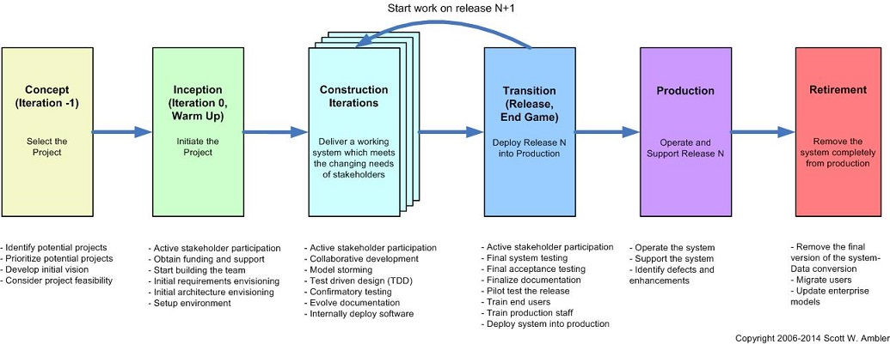

Source: (PMI, 2021)

Figure 2. Software Development Life Cycle (SDLC) Methodologies

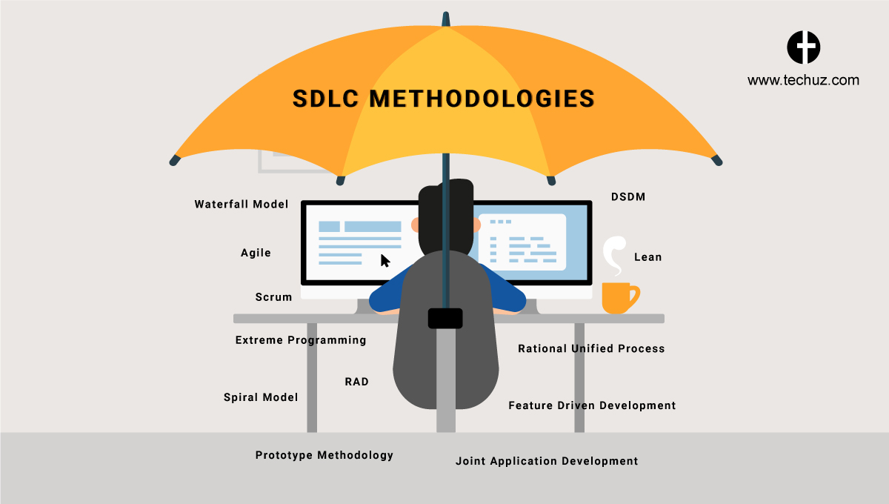

Source: (Techuz, 2018)

Figure 3. The Disciplined Agile (DA) Layers

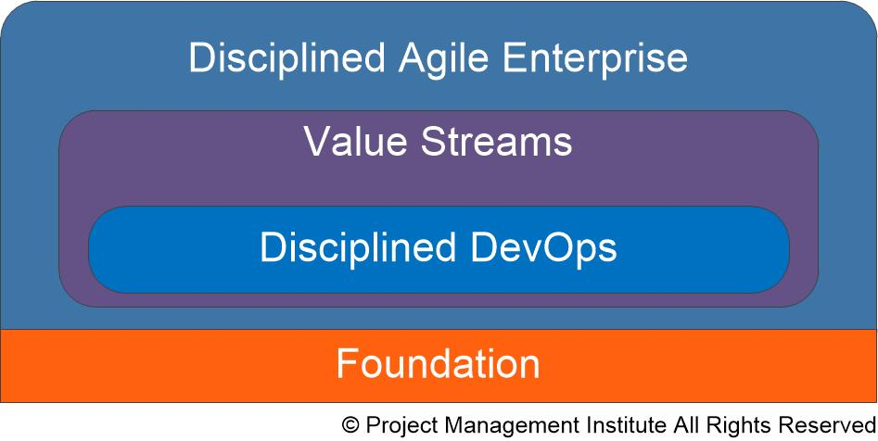

Source: (PMI, 2021)

Figure 4. The Disciplined Agile (DA) Tool Kit

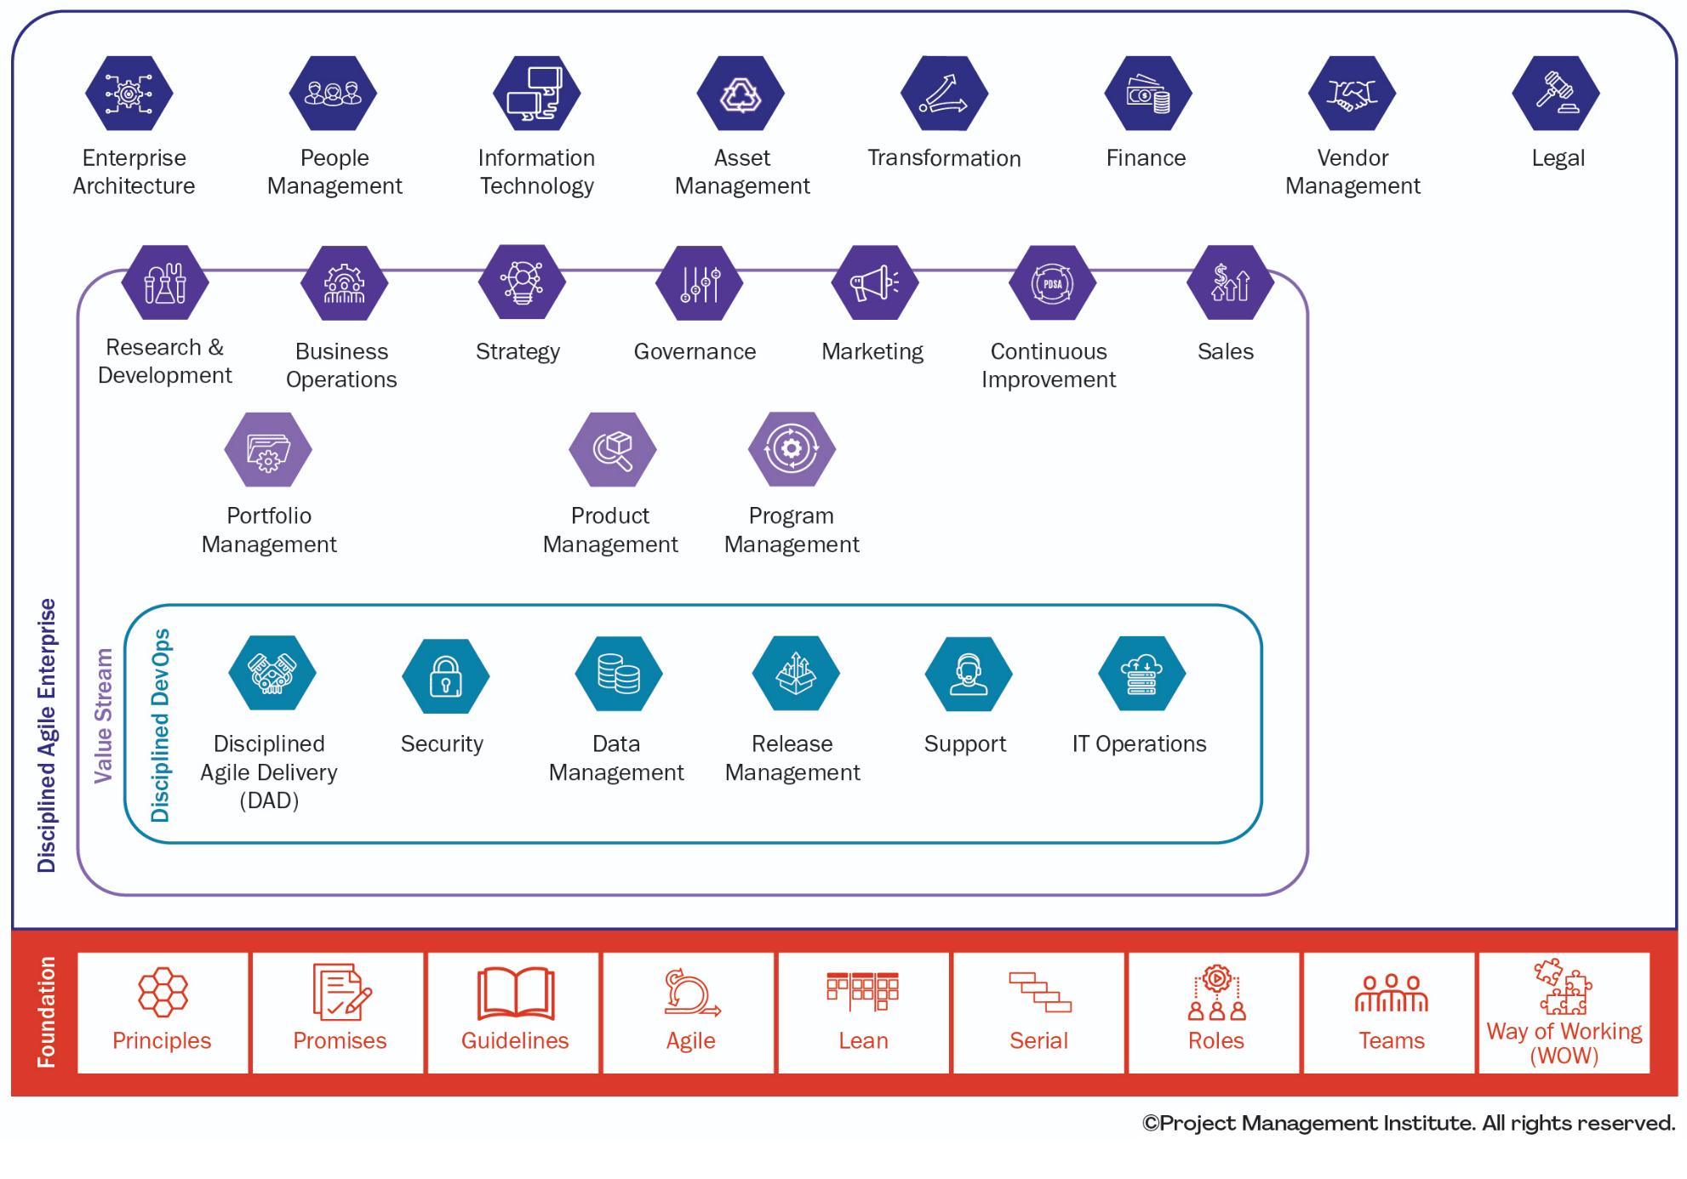

Source: (PMI, 2021)

Figure 5. Database Design Process Stage – Conceptual

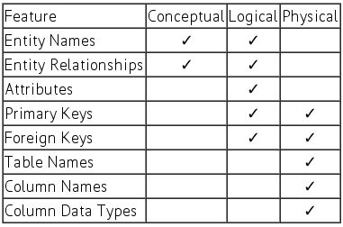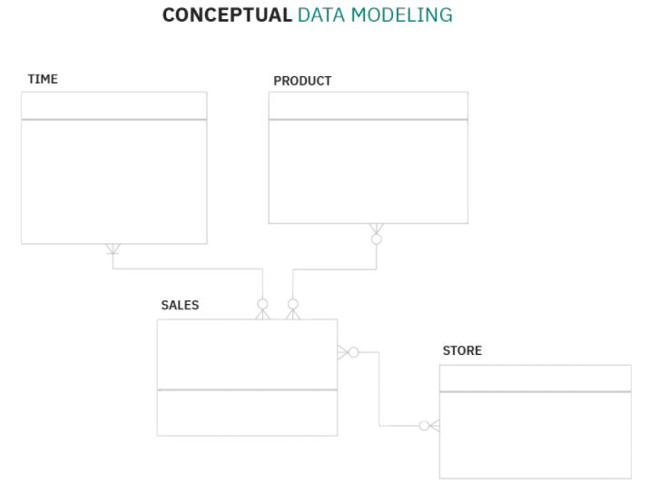

Source: (IBM, 2021)

Figure 6. Database Design Process Stage – Logical

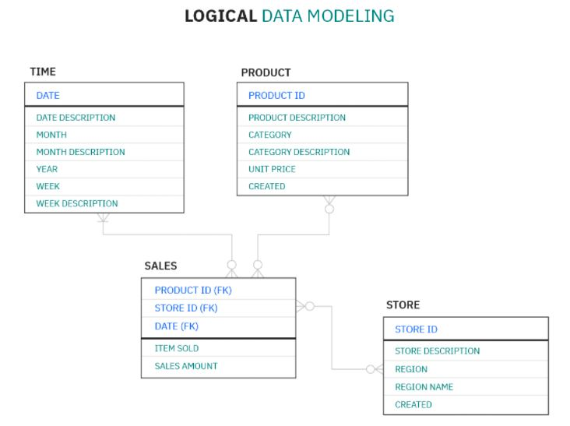



Source: (IBM, 2021)

Figure 7. Database Design Process Stage – Physical

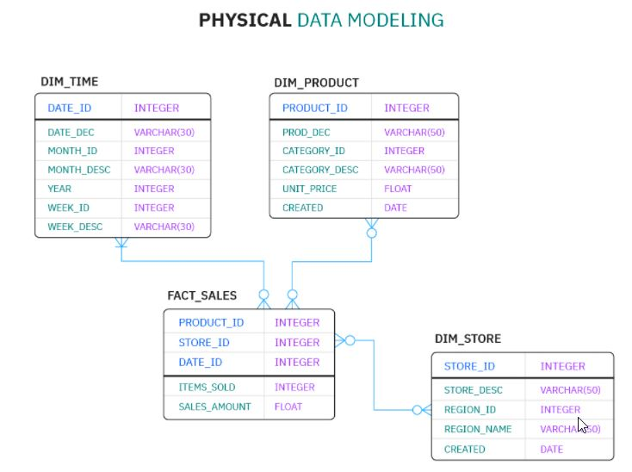



Source: (IBM, 2021)

|  |  |  |  |  |
| --- | --- | --- | --- | --- |
|  | | | | |
|  | References | | |  |
|  |  |  |  |  |
| DelVecchio, L. (2020). *What is inventory management process? flow explained.* <https://planergy.com/blog/inventory-management-process-flow/>  IBM. (2021). *What is data modeling?* <https://www.ibm.com/cloud/learn/data-modeling>  monday.com. (2020, -09-30T14:08:25+00:00). What is the agile SDLC? beginner's guide. <https://monday.com/blog/rnd/agile-sdlc/>  Neelu, L., & Kavitha, D. (2021). Estimation of software quality parameters for hybrid agile process model. *SN Applied Sciences, 3*(3), 296. 10.1007/s42452-021-04305-0  PMI. (2021). *Intro to disciplined agile | disciplined agile.* <https://www.pmi.org/disciplined-agile/introduction-to-disciplined-agile>  SKUBANA. (2020). *How to choose the best inventory management system.* <https://www.skubana.com/blog/inventory-management-system>  Sonmez, J. (2017, -07-19T07:41:28+00:00). All you need to know about software development methodologies! <https://usersnap.com/blog/software-development-methodologies/>  Techuz. (2018, -10-17T18:52:30+00:00). SDLC methodologies with pros & cons | software development lifecycle. <https://www.techuz.com/blog/top-12-sdlc-methodologies-with-pros-and-cons/> | | | | |